AXO API Documentation
System Overview
The AXO platform integrates four modular tools within a 3D printer–like motion framework through a unified control architecture:
- Dual Syringe Pump
- Spectrometer
- Vacuum Gripper
- Single Syringe Pump (or OT2 Pipettes, adapted from the Science-Jubilee project)
Architecture
Each module interfaces through an independent control layer coordinated via:
- G-code: The primary command language governing AXO hardware motion and tool operations.
- JSON Configuration Files: Define labware mappings, tool parameters, and system initialization settings.
- Python Interface: Serves as the orchestration layer, interpreting G-code, managing configurations, and coordinating inter-tool operations.
Table of Contents
Axo API Documentation 1
Wiring Diagram 1
Dual Syringe Pump 2
Spectrometer 7
Vacuum Gripper 12

Wiring Diagram
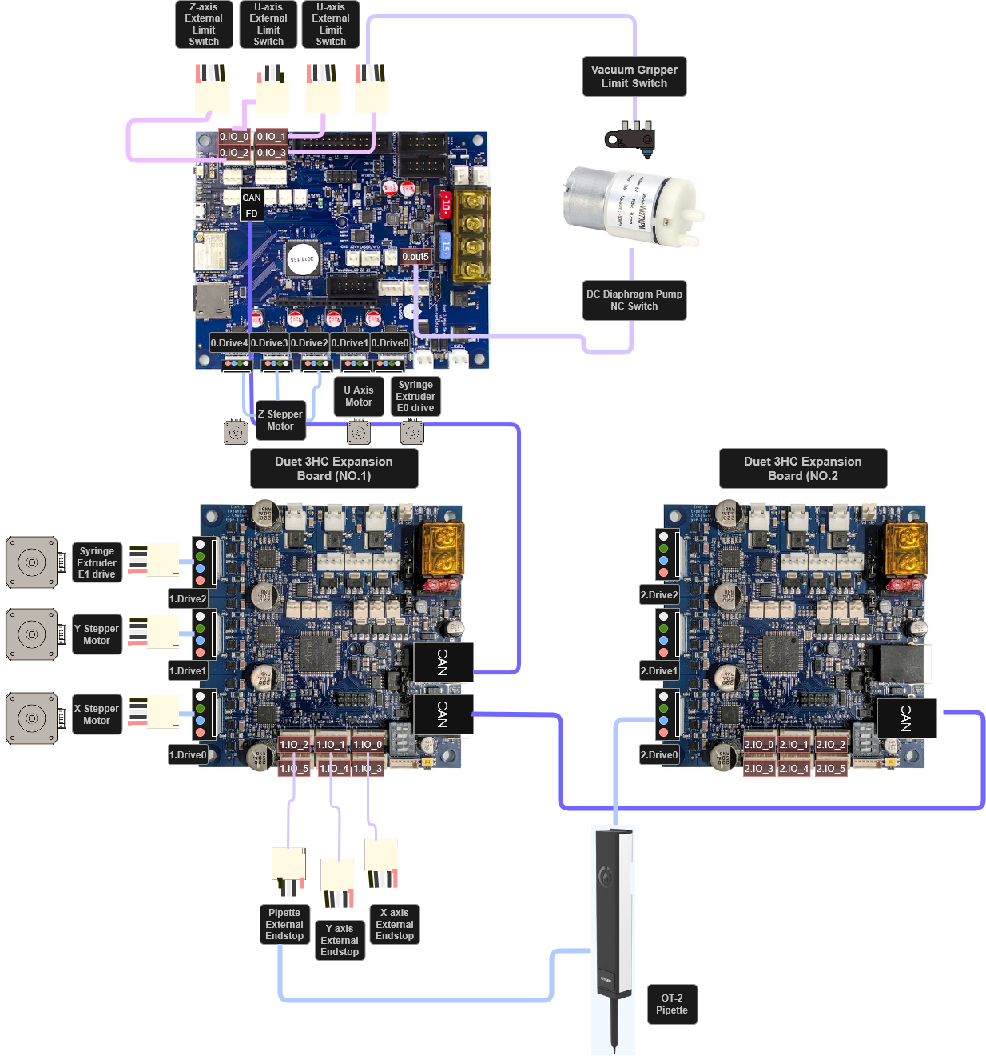

Note : There is no need to explicitly follow this wiring diagram.

Dual Syringe Pump
Note: The Dual Syringe Pump API is adapted from the original SyringeExtruder.py provided by the Jubilee collaborators. However, our implementation introduces significant modifications, including automatic refill and aspiration routines. These enhancements eliminate redundant motions and remove the need for tool-changing mechanisms, optimizing the system specifically for materials synthesis workflows.

Dual Syringe Pump config.g Setup
To configure the Dual Syringe Pump, add the following lines to the config.g file located in the Jubilee/src directory:

—-----------------------------------------------------------------------------------------------------------------
; Dual Syringe Pump Configuration

M584 E0.0:1.2 R0 S1
M569 P1.2 S1 ; Syringe Motor direction (for E1, expansion board)
M569 P0.0 S1 ; Syringe Pump Motor direction (for E0, mainboard)
M906 E{0.85*sqrt(2)*1400}:{0.85*sqrt(2)*1400} ; Syringe Pump: 85% of 1400mA RMS for both E0 and E1
M350 E16:16 I1 ; Enable 16x microstepping for both extruder drives (E0 and E1)
M92 E3200:3200 ; Steps/mm for both drives (E0, E1) of the Double Syringe Pump
M201 E1000:1000 ; Acceleration for both extruder drives (E0, E1)
M203 E1000:1000 ; Maximum speeds for both extruder drives (E0, E1)
M566 E500:500 ; Jerk settings for both extruder drives (E0, E1)
M563 P2 S"Syringe_Pump_r" D0:1 ; Tool 2: Syringe Pump using drives 0 and 1 (E0 and E1)
—--------------------------------------------------------------------------------------------------------------------

Dual Syringe Pump API (Double_Syringe.py)

Initialization & Configuration

__init__(...)
- Initializes the DoubleSyringe object, sets up tool metadata (like plunger range, conversion factor mm_to_ml), and loads the syringe config from a JSON file.

load_config(config: str)
- Loads parameters like min_range, max_range, and mm_to_ml from a config file in /tools/configs.
- Verifies that all required fields are present.

post_load()
- Queries the firmware for the tool’s extruder (E) assignments and stores them as self.e0_drive and self.e1_drive (e.g., "E0", "E1").
- Must be called after the tool is loaded into the machine.

check_bounds(pos)
- Verifies that a target plunger position pos is within physical limits.
- Throws ToolStateError if movement is unsafe.

Helper Function for Syringe Motions
In the Dual Syringe Pump, we do not use direct dispensing commands. Instead, the system is designed to automatically refill both syringes by driving them to the end of their respective coordinate ranges.

_aspirate(vol, drive, s)
- Moves the specified syringe backwards to aspirate a given volume.
- Checks for overfilling and clamps if needed.
- Returns the actual aspirated volume.
- S : FeedRate (Speed of the motors)

_refill(drive, s)
- Moves the plunger to the max position (full) for the given drive, as a full refill.
- Only handles plunger motion—not well positioning.

_plunger(drive, delta_mm, s)
- Performs a plunger movement (positive or negative) by a specified distance in relative extrusion mode.
- Switches between relative (M83) and absolute (M82) modes as needed.

Basic High-Level Syringe Commands

refill(drive, refill_loc, s)
- Moves the tool to the refill location and performs a full refill using _refill.

aspirate(vol, location, s)
- Moves the tool to a well and aspirates a given volume.
- Uses _aspirate after moving to the coordinates.

dispense(vol, location, s)
- Moves the tool to a well and dispenses a given volume.
- Uses _dispense (which seems missing in the code and replaced by _move_channel).

Drive-Specific Coordinate Helpers

_xy_for_drive(drive, loc)
- If the drive is E0, adds offset_x to the x-coordinate. (You can switch your drive on your choice but offsets between the needles should be calculated from the center of each syringe pump)
- Ensures the right(or left) syringe dispenses at the correct x-shifted location.

Unified Aspirate/Dispense Handler

_move_channel(drive, loc, vol, s, dispense, refill_loc)
- Core handler for both aspirate and dispense:
  - Calculates required travel.
  - Handles overfill (for aspirate) or underflow (for dispense) with auto-refill.
  - Moves to correct position and performs plunger motion.
  - Returns volume moved in mL.
- Uses _xy_for_drive() to account for offset_x.

Wrappers for Dual Channels
To simplify high-level control, the following wrapper functions abstract the direct calls to _move_channel(). These wrappers are designed for clean and readable usage in automation scripts and protocols.

aspirate_e0(vol, refill_loc_e, s)
- Aspirates using the E0 drive.

dispense_e0(vol, sample_loc_e, refill_loc_e, s)
- Dispenses using E0, with auto-refill if needed.

aspirate_e1(vol, refill_loc_v, s)
- Aspirates using E1.

dispense_e1(vol, sample_loc_v, refill_loc_v, s)
- Dispenses using E1, with auto-refill if needed.

Reset Plungers to Zero

reset_position(s)
- Moves both syringes to position 0 (fully dispensed)
- Useful to initialize or finalize a run.
- No axis mapping in Syringe Pump, better to reset to position 0.

Spectrometer
Note: For AXO, the Spectrometer API is built on the proprietary OceanDirect SDK provided by Ocean Optics and serves as a central controller that orchestrates the spectrometer’s interaction with other hardware components. It directly interfaces with the OceanDirect API for real-time spectral acquisition while coordinating machine motion through machine.py and precise well positioning via labware.py. This integration enables synchronized control across devices, allowing the spectrometer to trigger or respond to robotic actions dynamically. Additionally, the API supports flexible data processing routines, making it well-suited for automated, multi-well material characterization workflows.

Spectrometer config.g Setup
To configure the Spectrometer within the AXO system, add the following line to the config.g file located in the Jubilee/src directory:

—-----------------------------------------------------------------------------------------------------------------
M563 P3 S"Spectrometer"
—--------------------------------------------------------------------------------------------------------------------

Spectrometer API (Oceandirect_axo.py)

Initialization & Setup

__init__(...)
- Initializes the spectrometer tool, directory structure, and reference spectra.
- Calls open_spectrometer() and _load_references() to auto-connect and recover white/dark spectra.
- Creates:
  - base_dir: root folder for saving data (e.g., "Spectra/")
  - plate_dir: session folder (e.g., "Spectra/20250601/")
  - ref_dir: folder to store dark/white references

Device Management

find_spectrometers()
- Scans for connected Ocean Insight spectrometers.
- Returns a list of available device IDs.

open_spectrometer()
- Opens the first available spectrometer and returns it.
- Saves the spectrometer and device ID to self.spectrometer and self.device_id.

close_spectrometer()
- Closes the active spectrometer connection cleanly.

Configuration

configure_device(integration_time_us, scans_to_avg, boxcar_width)
- Sets integration time (exposure), scan averaging, and boxcar width (smoothing).

lamp_shutter(open)
- Opens/closes the internal shutter, if supported by the spectrometer hardware.

Measurement & Processing

measure_raw_spectrum()
- Returns (wavelengths, intensities) as NumPy arrays.

compute_absorbance(sample_vals, dark_vals, white_vals, eps, clip)
- Computes absorbance spectrum from raw data:
$A\left(λ\right) = -\log_{10 }\left(\frac{I_{sample }-I_{dark}}{I_{white}-I_{dark}+ε }\right)$

- Adds eps to avoid division by zero and optionally clips values.

Measurement Workflow

position_probe(location)
- Moves the stage above the specified well location using Labware._getxyz().
- Saves the current well and location for downstream reference.

collect_spectrum(location, elapsed_min, open, save)
- Core function for acquiring a spectrum:
  - Positions the probe
  - Opens/closes shutter if needed
  - Measures raw spectrum
  - Converts to absorbance
  - Saves to CSV (if save=True) with time-stamped metadata

Reference Spectra Handling
Once a reference spectrum has been collected, it can be reused in subsequent measurements to ensure consistent calibration and comparison. The system automatically stores reference spectra in the base_dir/ref directory. You can load and apply a previously captured reference by calling it from this path, eliminating the need to re-capture reference data for every session.

set_dark(n_avg)
- Averages n_avg dark readings and stores in ref_dir with a timestamped filename (e.g. dark_20250601_112300.npy).

set_white(n_avg)
- Same as above, but for white reference.

_load_references()
- Tries to load the most recent timestamped dark_* and white_* files.
- Falls back to dark.npy / white.npy if newer refs not found.

_latest_ref(prefix)
- Utility that returns the most recent reference file path based on prefix ("dark" or "white").

Storage and Metadata

set_storage_root(new_root)
- Changes all directory roots to a new base (e.g., switching between experiments).

_csv_path(well_id)
- Returns a path like Spectra/20250601/A1.csv.

_ensure_file(path, meta)
- Creates the file with a YAML-style metadata header if it doesn't exist.

_append_spectrum_csv(well_id, time_min, wl, absorbance, meta)
- Appends a new absorbance column to a .csv file for the specified well, with time (<time_min> min) as column label.
- Preserves YAML-style metadata in the header.

read_spectrum_csv(path)
- Reads a saved .csv file and returns both metadata and absorbance DataFrame.

Global Utility Functions

_yaml_header(meta)
- Formats metadata dictionary as a block comment header in YAML-style (for readability and parsing).

_parse_header(path)
- Parses and returns the header block as a dictionary + number of lines used.

Vacuum Gripper
Note: Vacuum Gripper leverages both hardware-level G-code execution and Python-based software abstraction for automated pick-and-place workflows. We implemented the control logic for a vacuum-powered gripping tool. It combines movement planning, GPIO vacuum control, and contact-based probing.
In order to use the Vacuum Gripper you need an NC or NO limit switch and pin it through DUET3D, or else you need to hardcode the picking z-location for appropriate contact.
*To use multiple z-probe, firmware should be updated to 3.5>
*Firmware mismatch of Mainboard(Duet3D mini 5+, Duet3D expansion 3HC) causes improper I/O pin behavior or failure.

Vacuum Gripper Config.g Setup
To configure the Vacuum Gripper for use with the Duet3D Expansion 3HC board, add the following lines to your config.g file located in the Jubilee/src directory:

—-----------------------------------------------------------------------------------------------------------------
M558 K2 P8 C"^1.io3.in" ; Expansion Board 3HC board number 1 at io3 port, in & ground.
;"Control Point" ; Offset it downwards slightly so we don't smear it along
; the bed while traveling when z=0.
G31 K2 P100 X0 Y0 Z-vacuum_gripper_offsets ; Set the limit switch as the

M563 P4 S"Vacuum_Gripper" ; Define Tool 4 named "Vacuum_Gripper"
—--------------------------------------------------------------------------------------------------------------------

Vacuum Gripper API

Initialization

__init__(index, name, vacuum_pin, limit_switch_pin)
- Initializes the gripper, storing:
  - vacuum_pin for PWM control (e.g., Duet's M42 P<vacuum_pin> S<pwm>) PWM is the drive voltage to the pump.
  - limit_switch_pin for Z-probe trigger (e.g., Duet's G30 K<switch>)
- Throws error if either pin is not provided

grip(location, pwm, retract_z_after_probe)
- Pick up an object at a given location:
  - Moves in Z safely
  - Moves to x, y
  - Starts vacuum (M42 P... S<pwm>)
  - Lowers Z until limit switch (Z-probe) is triggered via G30 K<switch> S-1
  - Optionally retracts Z after probing
S-1 means probe but don’t update the Z offset, keeping bed leveling safe

drop(location, retract_z_after_probe)
- Release object at a target location:
  - Moves safely in Z
  - Moves to x, y
  - Triggers Z-probe for contact release
  - Stops vacuum (M42 P... S0)

_probe_limit_switch(retract_z_after_probe)
- Sends G-code:
  - G30 K<limit_switch_pin> S-1 to probe Z until the limit switch is triggered
  - move(dz=...) to retract Z afterward

pick_and_place(grip, drop, pwm, retract_z_after_probe)
- High-level macro
  - Calls grip() at the pickup location
  - Moves to drop() location
  - Finishes with safe Z retraction

